Name: Justin V Kalappura
Roll No: 10
Batch: MCA
Date: 09/05/2022

NETWORKING & SYSTEM ADMINISTRATION LAB

Experiment No.: 18

Aim:
Write a program to find the factorial of a number.

Procedure:

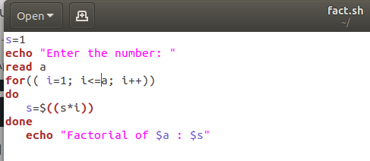

Output Screenshot:

